 | Anjuman-I-Islam’s  M. H. SABOO SIDDIK COLLEGE OF ENGINEERING  8, Saboo Siddik Polytechnic Road, Byculla, Mumbai, Maharashtra 400008  DEPARTMENT OF INFORMATION TECHNOLOGY

A Project Report
on
“CoreLLM: Building a Large Language Model Inference Engine”
Submitted in partial fulfilment of the requirements of the
ITP701 Major Project – I
Bachelor of Engineering in Information Technology (Semester VII)
Group No. 5
By
Harsh Desai (231416)
Himanshu Mishra (231417)
Rasil Khan (231462)
Kiran Jadhav (231419)
Under the guidance of
Er. Farzana Khan
REV - 2019 ‘C’ Scheme

University of Mumbai
Academic Year (2026-27)

DECLARATION
We declare that this written submission represents our ideas in our own words and where others’ ideas or words have been included, we have adequately cited and referenced the original sources. We also declare that we have adhered to all principles of academic honesty and integrity and have not misrepresented or fabricated or falsified any idea/data/fact/source in our submission. We understand that any violation of the above will be cause for disciplinary action by the Institute and can also evoke penal action from the sources which have thus not been properly cited or from whom proper permission has not been taken when needed.

Students’ Name, Roll Number and Signature
Harsh Desai 231416 ………………
Himanshu Mishra 231417 ………………
Rasil Khan 231462 ………………
Kiran Jadhav 231419 ………………

Date:
Place: Mumbai

CERTIFICATE
This is to certify that the project entitled “CoreLLM: Building a Large Language Model Inference Engine” is a bona fide work of “Harsh Desai” (231416), “Himanshu Mishra” (231417), “Rasil Khan” (231462) and “Kiran Jadhav” (231419) submitted to the University of Mumbai in partial fulfillment of the requirements for the ITP701 Major Project-I of 7th Semester in Department of Information Technology.

(Er. Farzana Khan)  Project Guide | (Dr. Zainab Mirza)  Head of Department

(Dr. Shafi Pathan)
Principal

PROJECT REPORT APPROVAL
This project report entitled “CoreLLM: Building a Large Language Model Inference Engine” is a bona fide work of “Harsh Desai” (231416), “Himanshu Mishra” (231417), “Rasil Khan” (231462) and “Kiran Jadhav” (231419), is approved for the ITP701 Major Project-I for the 7th semester.

Examiners
1) ---------------------------------------
2) ---------------------------------------

Date:
Place: Mumbai

ACKNOWLEDGEMENT
We, the project team, would like to express our sincere gratitude to everyone who contributed to this project. First and foremost, we thank our project guide, Er. Farzana Khan, for the guidance and encouragement provided throughout the work. We also thank our Major Project Coordinator, Er. Shrinidhi Gindi, for coordinating the Major Project-I activities.
We are grateful to Dr. Zainab Mirza, Head of the Department of Information Technology, and to the faculty and staff of Anjuman-I-Islam’s M. H. Saboo Siddik College of Engineering for providing the academic environment and resources needed for this work.
Finally, we thank our families and classmates for their patience and support during the preparation of this report.

ABSTRACT
: Building a Large Language Model Inference Engine is a Major Project-I study of how a large language model (LLM) can run fully on a local computer. Most apps that use LLMs send every request to a cloud service. This needs the internet, shares user data with another company, and brings usage limits and costs. The technical base of this project is the research paper “A Foundational Approach to Local Large Language Model Execution”. The paper describes a five-layer framework for running an LLM locally: the hardware layer, the model layer, the inference engine layer, the augmentation layer, and the interface and orchestration layer.
For each layer the report explains the main limit and the choice made in CodeHaven, an offline coding assistant for students that the research paper uses as its working example. CodeHaven runs a 4-bit coding model (qwen2.5-coder) through Ollama on a laptop with 16 GB of RAM and no GPU. It also searches the student’s own notes on the device, using nomic-embed-text embeddings and a vector store written from scratch. The report shows the memory needed at different quantization levels, the published scores of three 7B-class coding models, how a question moves through the five layers, and the trade-offs between capability, privacy and hardware.
The report uses the evidence given in the source paper and adds no new test results. It concludes that local execution cannot fully replace cloud LLMs, but it works well when privacy, offline use or cost matter and the task is clear. Future work includes routing requests between local and cloud models, testing lower-bit quantization and pruning for 8 GB machines, adding voice input, and building a small benchmark that compares local assistants on different hardware.
Keywords: Local Large Language Models, LLM Inference Engine, Quantization, GGUF, llama.cpp, Ollama, Retrieval-Augmented Generation, Offline AI.

TABLE OF CONTENTS
Sr. No. | Content | Page No.
 | TITLE PAGE | i
 | DECLARATION | ii
 | CERTIFICATE | iii
 | PROJECT REPORT APPROVAL | iv
 | ACKNOWLEDGEMENT | v
 | ABSTRACT | vi
 | LIST OF FIGURES | viii
 | LIST OF TABLES | viii
1 | CHAPTER 1: INTRODUCTION  1.1 Project Overview; 1.2 Problem Statement; 1.3 Objectives and Scope | 1
2 | CHAPTER 2: LITERATURE SURVEY  2.1 Introduction; 2.2 Research Papers and Tools; 2.3 Summary of Related Work | 4
3 | CHAPTER 3: METHODOLOGY  3.1 Introduction; 3.2 System Design; 3.3 Team Roles and Contribution | 8
4 | CHAPTER 4: DESIGN / IMPLEMENTATION  4.1 Block Diagram; 4.2 System Architecture; 4.3 Memory Requirements, Quantization and Model Selection; 4.4 Data Flow: Retrieval-Augmented Pipeline; 4.5 System Workflow; 4.6 Module Description of the Working Example; 4.7 Privacy and Offline Design; 4.8 Status Reporting | 10
5 | CHAPTER 5: HARDWARE AND SOFTWARE REQUIREMENTS  5.1 Hardware Requirements; 5.2 Software Requirements | 17
6 | CHAPTER 6: TESTING / RESULT AND ANALYSIS  6.1 Results Reported in the Source; 6.2 Published Benchmark Scores; 6.3 Analysis; 6.4 Test Cases for the CoreLLM Project | 18
7 | CHAPTER 7: SNAPSHOTS  7.1 Main Window (Code Chat); 7.2 Notes & Q&A (RAG); 7.3 Exam Generator; 7.4 Generate Code; 7.5 Debug Assistant; 7.6 Local Storage & History | 20
8 | CHAPTER 8: TIMELINE CHART | 26
9 | CHAPTER 9: FUTURE SCOPE  9.1 Routing between Local and Cloud Models; 9.2 Lower-bit Quantization and Pruning; 9.3 Benchmark across Hardware Tiers; 9.4 Larger Models for Better Hardware; 9.5 Terminal-Based Local Inference Engine (Lumen Direction) | 27
10 | CHAPTER 10: CONCLUSION  10.1 Achievement of Objectives; 10.2 Key Learnings; 10.3 Limitations and Trade-Offs; 10.4 Social and Educational Impact; 10.5 Final Remarks | 28
11 | REFERENCES | 30

LIST OF FIGURES
Sr. No. | Title | Page No.
1 | Figure 1: Five-layer framework of CodeHaven | 10
2 | Figure 2: Approximate model file size at common quantization levels (values from Table 4.1) | 13
3 | Figure 3: Published pass@1 scores of three 7B-class instruction-tuned coding models on HumanEval, MBPP and their EvalPlus versions | 14
4 | Figure 4: Path of a Notes question through the layers | 15
5 | Figure 5: CodeHaven main window | 20
6 | Figure 6: Notes & Q&A (RAG) screen of CodeHaven | 21
7 | Figure 7: Exam Generator screen of CodeHaven | 22
8 | Figure 8: Generate Code and Run in CodeHaven | 23
9 | Figure 9: Debug Assistant (Fix with AI) in CodeHaven | 23
10 | Figure 10: Local Storage & History panel, Chats tab | 24
11 | Figure 11: Local Storage & History panel, Notes Q&A tab | 24
12 | Figure 12: Local Storage & History panel, Exam Papers tab | 25
13 | Figure 13: Proposed 12-week project timeline (planned, not completed work) | 26

LIST OF TABLES
Sr. No. | Title | Page No.
1 | Table 2.1: Summary of related work and its role in CodeHaven (Table I of the research paper) | 6
2 | Table 3.1: Constraint and choice at each layer of the framework | 8
3 | Table 4.1: Approximate model file size by quantization level (Table II of the research paper) | 12
4 | Table 4.2: Stages of the local retrieval-augmented generation pipeline | 14
5 | Table 4.3: Steps of the request and the layer involved | 15
6 | Table 6.1: Observations reported in the research paper | 18
7 | Table 6.2: Published pass@1 scores (%) of three 7B-class instruction-tuned coding models [10] | 18

CHAPTER 1
INTRODUCTION

1.1 Project Overview
Large language models (LLMs) based on the transformer [1] are now part of everyday software such as chat assistants, code completion tools and document search. Open-weight models like LLaMA [2] can be downloaded and run by anyone. Still, most apps send every request to a cloud service, even when the model behind it is openly available.
CoreLLM: Building a Large Language Model Inference Engine is the Major Project-I of Group 5 of the Department of Information Technology. The project studies how an LLM inference engine fits into a complete local system. It is based on the research paper “A Foundational Approach to Local Large Language Model Execution”, which splits local LLM execution into five layers (hardware, model, inference engine, augmentation, and interface and orchestration) and states the main limit and the choice made for each layer.
The research paper uses CodeHaven, an offline coding assistant for students, as its working example. CodeHaven is a real working application. It runs a 4-bit quantized coding model through Ollama [9] on a laptop with 16 GB of RAM and no GPU. It offers Chat with a code runner, Notes Q&A with local document search, an Exam Paper maker and an offline Diagram maker. In this report CodeHaven is used only to explain the framework, and its screenshots are shown as proof of the working example. It is not a separate CoreLLM application.
Running a model on your own laptop became practical only recently. Two things came together: good open-weight models with 1 to 13 billion parameters, and quantization methods such as GPTQ [4] and AWQ [5]. These methods shrink a model to about a quarter of its size with only a small loss in quality. With a fast inference engine, a quantized 7B model runs well on a laptop with 8 to 16 GB of RAM.

1.2 Problem Statement

1.2.1 Problem Definition
Applications that depend on a cloud LLM API create everyday problems, particularly for students:
- Connectivity barrier: the tool stops working when the internet connection drops.
- Usage limits: free tiers have rate limits that tend to run out in the middle of a lab session or an assignment.
- Privacy risk: every prompt, including the code or notes pasted into it, goes to someone else’s server.
Xu et al. [3] report that delay, the risk of sending data out and recurring cost are the main reasons users prefer on-device models. So we need to understand how an LLM can run fully on ordinary laptop hardware, and which choices at each level make this possible.

1.2.2 Proposed Work
The project explains a five-layer framework for local LLM execution, from the hardware up to the user interface, with the inference engine in the centre. The report summarizes the related work behind each layer, explains the memory limits that make quantization a requirement, compares model choices using published benchmark scores, and follows a request through all five layers using CodeHaven as the working example.

1.2.3 Proposed Methodology
The system is built from the bottom up. The authors observed that “every choice near the bottom of the stack limits what is possible above it”, so the hardware limit is the starting point for every other design decision. The method therefore moves from the hardware layer (memory limit) to the model layer (quantized model), the inference engine layer (Ollama on llama.cpp), the augmentation layer (local retrieval) and finally the interface and orchestration layer (desktop app, routing and storage). Details of any CoreLLM-specific engine implementation beyond the source paper are [to be added by the project team].

1.3 Objectives and Scope

1.3.1 Objectives
The main objectives of the project are:
- To explain the five-layer framework for running an LLM entirely on a local machine.
- To show why memory is the main limit on a laptop and why quantization is a requirement and not an optional speed-up.
- To describe the model layer, including GGUF quantization levels and the file sizes they produce.
- To explain the role of the inference engine (Ollama on llama.cpp), the key-value cache and the context length.
- To explain how retrieval-augmented generation lets a quantized model answer questions about material it has never seen, without any data leaving the device.
- To describe the interface and orchestration layer, including local history storage and the desktop interface.
- To discuss the trade-offs between capability and privacy, hardware accessibility and hybrid deployment.

1.3.2 Scope
The scope of this report covers the following, all taken from the source paper:
- The five layers of local LLM execution and the choices made at each layer in CodeHaven.
- Approximate memory requirements at 3B, 7B and 13B parameter sizes and at 4-bit, 8-bit and 16-bit precision.
- A comparison of CodeLlama-7B-Instruct, DeepSeek-Coder-6.7B-Instruct and Qwen2.5-Coder-7B-Instruct using the published scores reported in the Qwen2.5-Coder technical report [10].
- The CodeHaven working example: Chat with a code runner (code generation and debugging), Notes Q&A, Exam Generator and Diagram maker, for Python and JavaScript students.
The project does not claim new experimental findings. Latency measurements on student laptops, lower-bit quantization, pruning and local/cloud routing are identified in the source as future work (Chapter 9).

CHAPTER 2
LITERATURE SURVEY

2.1 Introduction
The literature survey follows the related work section of the research paper and its ten references. These works cover the transformer and open-weight models, model compression and quantization, on-device inference, retrieval-augmented generation, and local speech recognition. Together they provide the foundation for each layer of the framework (Table 2.1 and Figure 1).
The survey shows that quantization and efficient inference engines now make it possible to run 1–13 billion parameter models on laptop-class hardware, but that the existing works address individual pieces. The on-device survey of Xu et al. [3] explains why local execution is worth doing, but it does not describe a complete application that an end user can install. The framework used in this project starts from this point and treats the hardware limit as the input to every other design decision.

2.2 Research Papers and Tools
Paper 1: Attention Is All You Need
Authors: A. Vaswani et al.
Published: 2017 (NeurIPS)
The transformer architecture on which present-day large language models are based [1]. The research paper cites it as the starting point of the LLMs that now appear in chat assistants, code completion tools and document search.
Paper 2: LLaMA: Open and Efficient Foundation Language Models
Authors: H. Touvron et al.
Published: 2023
An example of open-weight models that can be downloaded and run by anyone [2]. It illustrates that the model behind an application can be openly available even when the application still calls a cloud API.
Paper 3: On-Device Language Models: A Comprehensive Review
Authors: J. Xu et al.
Published: 2024
A survey of on-device language models covering efficient architectures, compression, hardware acceleration and edge–cloud collaboration [3]. It reports that latency, the risk of sending data out and recurring cost are the main reasons users prefer on-device models. It is the motivation for the layered design.
Paper 4: GPTQ: Accurate Post-Training Quantization for Generative Pre-trained Transformers
Authors: E. Frantar, S. Ashkboos, T. Hoefler and D. Alistarh
Published: 2023 (ICLR)
GPTQ quantizes one layer at a time and uses approximate second-order information to keep the output error small, so that large models can be reduced to 3 or 4 bits per weight with little loss in accuracy [4]. It explains why a 7B model fits in laptop RAM. Limitation: it needs a calibration dataset.
Paper 5: AWQ: Activation-aware Weight Quantization for On-device LLM Compression and Acceleration
Authors: J. Lin et al.
Published: 2024 (MLSys)
AWQ starts from the observation that only a small share of weight channels matters most to the output. It uses activation statistics to find these channels and scales them so that they survive quantization [5]. It is a second route to 4-bit models and also needs calibration data.
Paper 6: llama.cpp: LLM Inference in C/C++
Authors: G. Gerganov
Published: 2023 (GitHub repository)
Runs quantized models in plain C/C++ on a CPU, with optional GPU offload [6]. The GGUF format it uses stores quantized weights together with the metadata needed to run them quickly on a CPU. It is the engine underneath Ollama. Limitation: it is a command-line tool with no application features.
Paper 7: Retrieval-Augmented Generation for Knowledge-Intensive NLP Tasks
Authors: P. Lewis et al.
Published: 2020 (NeurIPS)
Retrieval-augmented generation (RAG) fetches relevant passages from an external collection at query time and gives them to the model along with the question [7]. The original work used a large Wikipedia index. The same idea works at a much smaller scale as a local vector store over a student’s own notes.
Paper 8: Robust Speech Recognition via Large-Scale Weak Supervision (Whisper)
Authors: A. Radford et al.
Published: 2022
Whisper was trained on a large amount of weakly labelled multilingual audio and transcribes speech accurately [8]. Its C/C++ port, whisper.cpp, runs on a CPU, so it can work offline next to a local LLM. Limitation: it is heavy for laptops if run as-is.
Paper 9: Ollama: Get up and running with large language models locally
Authors: Ollama Inc.
Published: 2024
Downloads, manages and serves local models through a simple API [9]. It is built on llama.cpp and is the inference runtime used in the working example. It has no document search, voice or user interface of its own.
Paper 10: Qwen2.5-Coder Technical Report
Authors: B. Hui et al.
Published: 2024
The report from which the published HumanEval and MBPP pass@1 scores in Figure 3 are taken [10]. The Qwen2.5-Coder family is the model used in CodeHaven (7B for Deep mode and 1.5B for Fast mode).

2.3 Summary of Related Work
Table 2.1 reproduces the summary table of the research paper. For each work it gives what the work does, its main limitation and the role it plays in the working example.
Table 2.1: Summary of related work and its role in CodeHaven (Table I of the research paper)
Work | What it does | Limitation | Role in CodeHaven
GPTQ [4] | Shrinks a trained model to 3–4 bits per weight, one layer at a time | Needs a calibration dataset | Explains why a 7B model fits in laptop RAM
AWQ [5] | Protects the few weight channels that matter most, using activation statistics | Also needs calibration data | Second route to 4-bit models
llama.cpp [6] | Runs quantized models in plain C/C++ on a CPU, with optional GPU offload | Command-line tool with no app features | Engine underneath Ollama
Ollama [9] | Downloads, manages and serves local models through a simple API | No document search, voice or UI | Our inference runtime (qwen2.5-coder)
Xu et al. [3] | Surveys on-device LLMs: compression, hardware, edge–cloud setups | A survey, not a working end-user tool | Motivation for the layered design
RAG [7] | Retrieves passages and gives them to the model with the question | Built around a large Wikipedia index | Small local version over students’ own notes
Whisper [8] | Multilingual speech recognition trained on large web audio | Heavy for laptops if run as-is | Planned offline voice input (future work)
CodeHaven (ours) | Chat, code running, debugging, notes Q&A and exam papers in one offline desktop app | Limited by a small model on student laptops | —
The reviewed work demonstrates that quantization can compress models to about 4 bits with little loss in quality, that llama.cpp and Ollama can run them on a CPU, that retrieval can ground answers in local documents and that speech recognition can also run on the device. What is missing in the existing work is a description of how these pieces fit together in an application that an end user can install. The five-layer framework fills this gap.

CHAPTER 3
METHODOLOGY

3.1 Introduction
The methodology of the project follows the structure of the research paper. When the authors started building CodeHaven they expected that running a model locally would simply mean replacing a cloud API call with a local one. In practice, every choice near the bottom of the stack limits what is possible above it. The system was therefore organized into five layers and described from the bottom up, stating at each layer what was used and why.

3.2 System Design
The framework consists of the following five layers, from the bottom of the stack to the top. The choice made in the working example at each layer is shown in the last column of Table 3.1.
Table 3.1: Constraint and choice at each layer of the framework
No. | Layer | Main constraint | Choice in CodeHaven
1 | Hardware | Memory (RAM) is the main limit on a laptop | Intel Core i7, 16 GB RAM, no discrete GPU, Windows 11
2 | Model | A 16-bit 7B model needs about 14 GB for its weights alone | qwen2.5-coder, 4-bit GGUF (7B about 4.7 GB, 1.5B about 1 GB)
3 | Inference Engine | Context length trades off against free memory through the key-value cache | Ollama on llama.cpp with a local HTTP API
4 | Augmentation | A quantized model only knows what it saw during training | Chunks, nomic-embed-text embeddings and our own vector store (local RAG)
5 | Interface & Orchestration | Everything must run without a network or cloud account | Electron app, FastAPI routing, SQLite history (voice input planned)

3.2.1 System Planning
Planning followed from the problems identified in Section 1.2.1:
- Identify what bothers students most about cloud-based AI coding assistants. The authors asked fellow students; three answers kept coming up: the tools need the internet all the time, the free tiers hit rate limits, and people are not comfortable sending their own code to an outside server.
- Treat these answers as the main requirements: offline operation, no usage limits and data that stays on the device.
- Fix the hardware limit first and treat quantization as a requirement.
- Select the model and the inference engine, then add retrieval and the interface layer on top.

3.2.2 Layered Design Approach
The design approach is layered and bottom-up. Each layer is chosen after the one below it because the lower layers limit what is possible above. The approach consists of the following stages:
- Hardware: record the processor, RAM, GPU and operating system of the target laptop.
- Model: choose a model size and quantization level that fits in the available memory.
- Inference engine: run the model with an engine that works on the CPU alone and manages the key-value cache; set the context length.
- Augmentation: add local retrieval for questions about the user’s own material.
- Interface and orchestration: build the desktop application that routes each request, stores the history and shows the results.
The approach keeps every layer replaceable with tools that already exist; the authors observe that every layer of the framework could be filled with tools that already exist.

3.3 Team Roles and Contribution
Team Member | Roll No | Role | Key Contributions | Contribution
Harsh Desai | 231416 | Documentation and Presentation Lead | Report preparation, documentation, research support, review, and presentations. | 23%
Himanshu Mishra | 231417 | Project Ideation and Technical Lead | Proposed the project idea, leads technical implementation, and will lead future development. | 27%
Rasil Khan | 231462 | Research and Presentation Lead | Research and technical analysis support, documentation support, and presentations. | 27%
Kiran Jadhav | 231419 | Research and Coordination Support | Research assistance, coordination, reminders, and review support. | 23%
Total |  |  |  | 100%

CHAPTER 4
DESIGN / IMPLEMENTATION
This chapter describes the five-layer framework and the CodeHaven working example. Everything described is taken from the research paper, the CodeHaven application and its screenshots.

4.1 Block Diagram
Figure 1 is the block diagram of the framework. It shows the five layers as coloured bands, from the bottom (1) to the top (5). Each band lists what CodeHaven uses at that layer and the related work from Chapter 2 that it builds on.
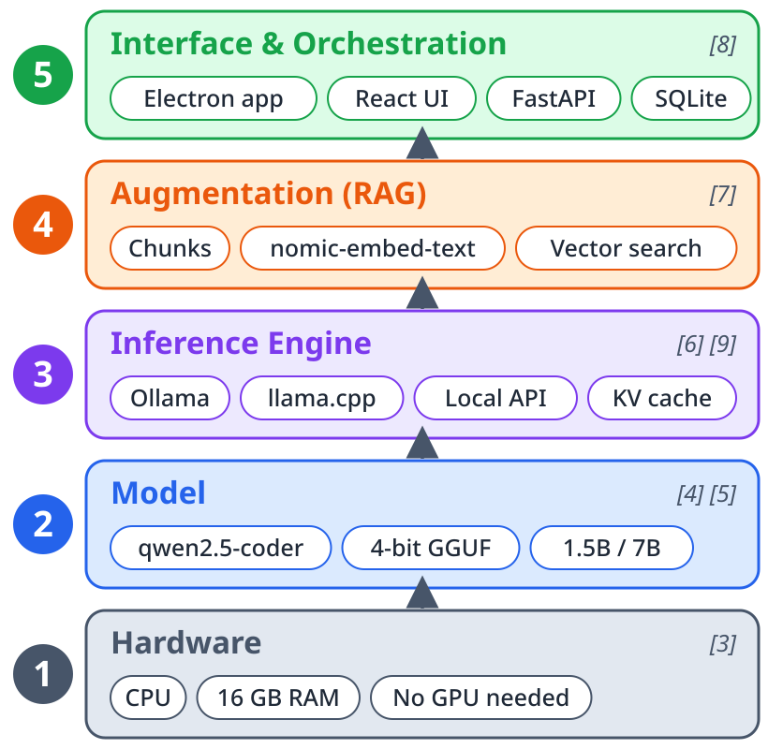
Figure 1: Five-layer framework of CodeHaven (redrawn for this report)

4.1.1 Detailed explanation of Figure 1
Figure 1 reads from the bottom to the top. The arrows between the bands show that each layer rests on the one below it, so the choices at the bottom limit everything above.
1. Hardware (related work [3]). Core i7, 16 GB RAM, no GPU, Windows 11. The survey of Xu et al. makes hardware the first design decision.
2. Model (related work [4], [5]). qwen2.5-coder in a 4-bit GGUF file: about 4.7 GB (7B, Deep) or about 1 GB (1.5B, Fast). GPTQ and AWQ explain why 4 bits is enough.
3. Inference Engine (related work [6], [9]). Ollama on llama.cpp, a local HTTP API, the key-value cache and the context length.
4. Augmentation (related work [7]). Notes are split into chunks, turned into nomic-embed-text embeddings and kept in a vector store that CodeHaven builds itself. Cosine similarity finds the closest chunks.
5. Interface & Orchestration (related work [8]). An Electron app, FastAPI routing and SQLite history. Voice input (whisper.cpp) is planned for later.

4.2 System Architecture

4.2.1 Layer 1 – Hardware Layer
Everything else depends on the machine. CodeHaven was built and tested on a laptop with an Intel Core i7 processor, 16 GB of RAM, no discrete GPU and Windows 11. Memory was the main limit. A 7B-parameter model stored in 16-bit precision needs about 14 GB for its weights alone (7 billion parameters at 2 bytes each), as expressed in Equation (1):
Memory ≈ parameters × bytes per parameter = 7×10⁹ × 2 ≈ 14 GB (1)
On a 16 GB laptop that leaves almost nothing for the operating system, the desktop app and the document index, and on an 8 GB laptop the model cannot be loaded at all. For this reason quantization is treated as a requirement, not as an optional speed-up.

4.2.2 Layer 2 – Model Layer
CodeHaven uses qwen2.5-coder at 4-bit quantization, stored in the GGUF format used by llama.cpp [6]. GPTQ [4] and AWQ [5] showed that weights can be squeezed to about 4 bits with little loss in quality, and the 4-bit GGUF formats follow the same idea. Table 4.1 lists typical file sizes and Figure 2 compares them with 8 GB and 16 GB of laptop RAM. The choice of model is discussed in Section 4.3.

4.2.3 Layer 3 – Inference Engine Layer
Ollama [9] loads and runs the model. It is built on llama.cpp [6], so it works on the CPU alone, can offload layers to a GPU when one is present, and manages the key-value cache during a conversation. Ollama has a local HTTP API, and the FastAPI backend sends all model requests to it. The main setting at this layer is the context length. A longer context means a larger cache and more RAM, so conversation length trades off directly against free memory. CodeHaven uses 2,048 tokens of context in Fast mode and 3,072 in Deep mode.

4.2.4 Layer 4 – Augmentation Layer
A quantized model only knows what it saw during training, so retrieval is added for questions about a student’s own material. In the Notes Q&A screen, a user uploads PDF, DOCX, TXT, Markdown, code or image files (scanned pages are read with OCR). CodeHaven cuts each file into chunks of about 700 characters, turns every chunk into an embedding with the nomic-embed-text model, and saves them in a vector store written from scratch in Python. When the user asks a question, the four closest chunks are found with cosine similarity and placed in the prompt, following the retrieval-augmented generation idea of Lewis et al. [7]. The answer is shown with its sources. The documents and the index stay on the device, so this layer needs no network. The stages are summarized in Table 4.2.

4.2.5 Layer 5 – Interface and Orchestration Layer
The top layer is an Electron desktop application (Figure 5). It has four screens: Chat, Notes Q&A, Exam papers and Diagrams, with a model picker at the top. In Chat the student can generate code, press Run to see the output, or press Fix with AI. The FastAPI backend sends each request to the right module. Chats, note sessions and exam papers are saved in a local SQLite database (codehaven.db), so the history is still there after a restart and no cloud account is needed. A status bar at the bottom shows the model state, the CPU and RAM use, and that no network is needed. Voice input is planned for later.

4.3 Memory Requirements, Quantization and Model Selection
Table 4.1: Approximate model file size by quantization level (Table II of the research paper)
Params | Quantization | Size | Typical use
3B | 4-bit (Q4_K_M) | ~2 GB | Quick autocomplete and short chat
7B | 4-bit (Q4_K_M) | ~4–5 GB | Coding help and notes Q&A (CodeHaven default)
7B | 8-bit (Q8_0) | ~7–8 GB | Slightly better output if RAM allows
13B | 4-bit (Q4_K_M) | ~7–8 GB | Better generation, needs a 16 GB machine
7B | 16-bit (F16) | ~14 GB | Too large for most laptops
Rounded values. Exact sizes depend on the model architecture and the quantization scheme [4]–[6].
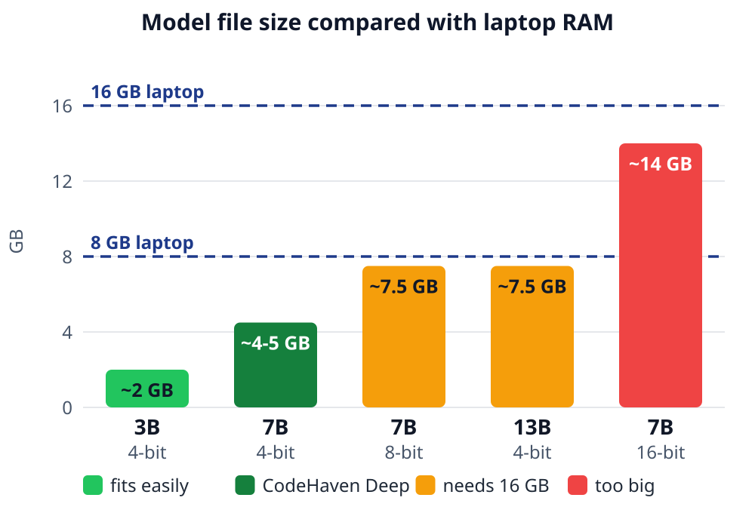
Figure 2: Approximate model file size at common quantization levels (values from Table 4.1). Dashed lines mark 8 GB and 16 GB of laptop RAM. Green means it fits easily, orange means it needs a 16 GB machine and red means it is too big. The dark green bar is the Deep mode setting used in CodeHaven.
A 3B model at 4-bit needs about 2 GB, and a 7B model at 4-bit needs about 4–5 GB, so both fit in 8 GB of RAM, although the 7B model leaves little room once the operating system and the app are running. The 8-bit 7B model and the 4-bit 13B model both need about 7–8 GB for the weights alone, which in practice means a 16 GB machine, and the unquantized 7B model does not fit comfortably in either. These are file sizes only. The running model also needs memory for its key-value cache, which grows with the context length, so real usage is higher. The 4-bit 7B model is the Deep mode because it gives the best quality that still leaves room on a student laptop. The 1.5B model (about 1 GB) is the Fast mode used in the screenshots.

4.3.1 Model selection
To pick the model itself, the authors tried CodeLlama, DeepSeek-Coder and Qwen2.5-Coder at the 7B size on their own coding and debugging prompts. Qwen2.5-Coder gave more accurate code and followed instructions better than the other two. The published scores in Figure 3 agree: on HumanEval and MBPP, and on their stricter EvalPlus versions, Qwen2.5-Coder-7B-Instruct scores highest, while CodeLlama-7B-Instruct is far behind [10].
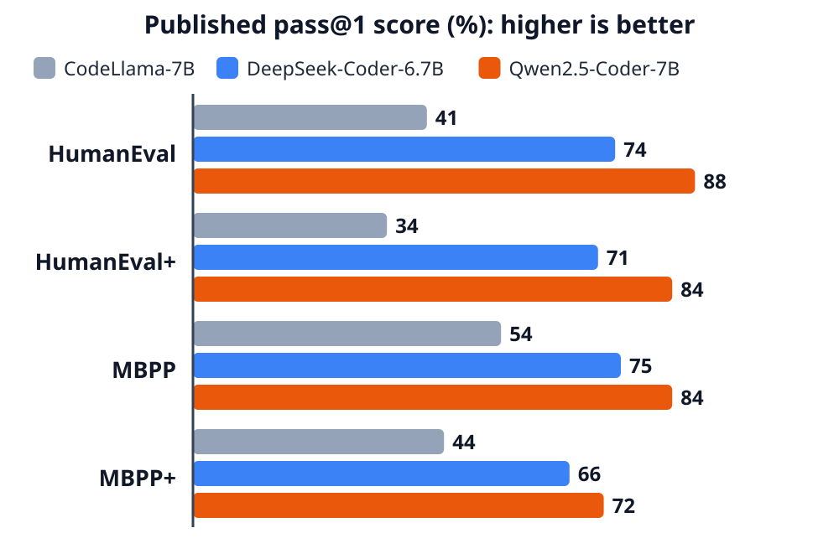
Figure 3: Published pass@1 scores of three 7B-class instruction-tuned coding models on HumanEval, MBPP and their EvalPlus versions (HumanEval+, MBPP+). Data from the Qwen2.5-Coder technical report [10]. Higher is better.

4.4 Data Flow: Retrieval-Augmented Pipeline
The augmentation layer processes a student’s notes in the stages of Table 4.2. All stages run on the device.
Table 4.2: Stages of the local retrieval-augmented generation pipeline
Stage | Description (from the research paper) | Where it runs
1. Upload | The user uploads PDF, DOCX, TXT, Markdown or code files in Notes & Q&A mode | Electron interface
2. Chunk | Each file is split into chunks of about 700 characters (a 21 KB sample PDF became 5 chunks) | On the device
3. Embed | The chunks are converted into embeddings with the nomic-embed-text model | On the device
4. Store | The embeddings are stored in a local vector store built from scratch (JSON files) | On the device
5. Retrieve | When a question is asked, the four closest chunks are found with cosine similarity | On the device
6. Generate | The chunks are placed in the prompt and qwen2.5-coder answers through Ollama; the answer is shown with its sources | Ollama, on the CPU

4.5 System Workflow
This section follows one request through the layers. A student uploads a lecture PDF in Notes Q&A and asks how merge sort works. Figure 4 shows the path of this request and Table 4.3 explains each step. No step in this chain uses the network.
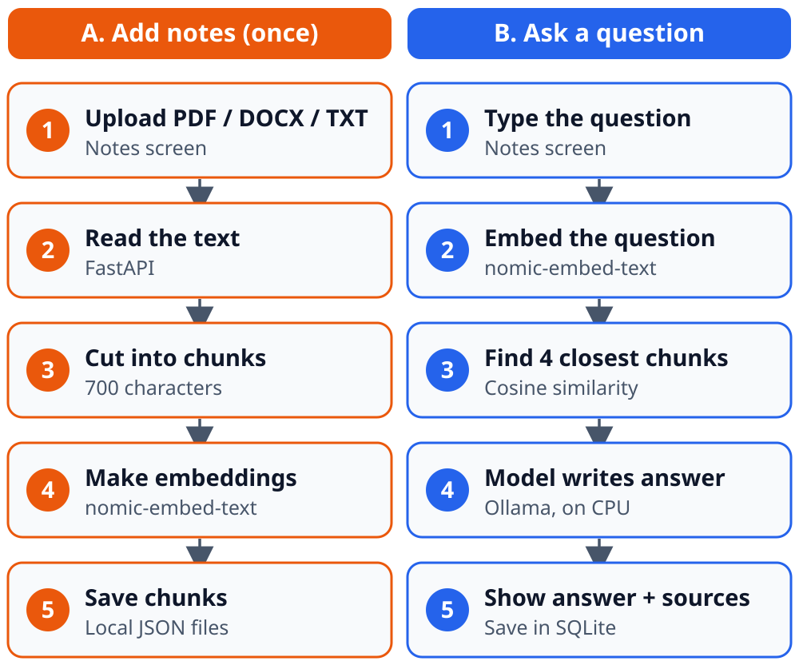
Figure 4: Path of a Notes question through the layers: adding the notes (left) and asking a question (right)
Table 4.3: Steps of the request and the layer involved
Step | What happens | Layer | Component
1 | The student types the question | Interface & Orchestration | Notes Q&A screen
2 | FastAPI sends the question to Ollama and gets an embedding back | Augmentation | FastAPI backend, nomic-embed-text
3 | The four closest chunks are found and added to the prompt | Augmentation | Local vector store (cosine similarity)
4 | The model produces the answer on the CPU | Inference Engine / Model | Ollama running qwen2.5-coder
5 | The answer is shown with its sources and saved | Interface & Orchestration | Electron app, SQLite

4.6 Module Description of the Working Example
CodeHaven has four screens (Figure 5 in Chapter 7 shows the main window). Code generation and debugging both happen inside Chat. The descriptions below follow the application and its screenshots.

4.6.1 Code Chat
A chat screen where the student talks to the local model. A model picker at the top right switches between Fast and Deep mode, and every code block has Copy and Run buttons.

4.6.2 Generate Code
The student describes the program to build and the model replies with a code block. Run opens a Terminal panel that runs Python, JavaScript, Bash, C, C++, Java and more, and shows the output. HTML pages get a live preview.

4.6.3 Debug Assistant
When code gives an error, the Terminal panel shows it with a Fix with AI button. The button sends the code and the error to the model, which explains the mistake and returns corrected code.

4.6.4 Notes & Q&A (RAG)
The student uploads notes and asks questions. The request goes through retrieval first (Section 4.2.4) and the answer is shown with its sources. A question can be limited to all notes or to one note.

4.6.5 Exam Generator
The Exam Settings panel takes the subject or course title, paper title, target notes, difficulty level (Easy, University, Hard), total marks and duration, and an option to include model answers and a step-by-step marking scheme. Generated papers are saved in the local database. The Diagrams screen draws SVG pictures from a text description, also offline.

4.7 Privacy and Offline Design
The working example is designed so that no step uses the network. The documents and the index stay on the device, the history is stored in a local SQLite database (codehaven.db) with no cloud account, code runs in a temporary folder on the same laptop, and the status bar shows that no network is needed. The history panel of the application itself states “100% Offline & Private”.

4.8 Status Reporting
The model picker at the top shows the loaded model and the Fast or Deep mode. A status bar at the bottom shows the ready state, CPU and RAM use. They show the state of the lower layers before a prompt is sent.

CHAPTER 5
HARDWARE AND SOFTWARE REQUIREMENTS

5.1 Hardware Requirements
The following hardware is the machine on which the working example was built and tested, as reported in the research paper:
Component | Requirement / Configuration
Processor | Intel Core i7
RAM | 16 GB (a 4-bit 7B model fits in 8 GB but leaves little room; a 16-bit 7B model needs about 14 GB)
Graphics | No discrete GPU; a GPU is optional and allows Ollama to offload layers
Storage | About 4.7 GB on disk for the 4-bit qwen2.5-coder:7b model (about 1 GB for the 1.5B model), plus the document index
Operating system | Windows 11
Microphone | Not needed now; only for the planned voice input

5.2 Software Requirements
The following software components are used in the working example:
Software | Purpose
Ollama | Local LLM runtime that loads and serves the model through a local HTTP API
llama.cpp | Engine underneath Ollama; runs quantized GGUF models on the CPU
qwen2.5-coder (4-bit GGUF; 7B and 1.5B) | Code language model
nomic-embed-text | Embedding model for the retrieval pipeline
Own vector store (Python) | Local store of document chunks with cosine-similarity search
Whisper with whisper.cpp (planned) | On-device speech recognition for the future voice input
Electron | Desktop application shell
FastAPI | Backend that routes each request to the right module
SQLite (codehaven.db) | Local storage of chats, note sessions and exam papers
The project needs Python 3.11 or newer and Node.js 20 or newer (from the project README).

CHAPTER 6
TESTING / RESULT AND ANALYSIS
The research paper reports measurements and observations from building the working example; it does not publish a test-case table or latency measurements. This chapter therefore presents only the results that the source supplies. No test results have been added.

6.1 Results Reported in the Source
Table 6.1: Observations reported in the research paper
Item | Observation
Configuration | 4-bit quantized 7B model (qwen2.5-coder:7b) run through Ollama on a laptop with 16 GB RAM and no GPU
Model file | About 4.7 GB on disk (4-bit GGUF)
Memory of a 16-bit 7B model | About 14 GB for the weights alone
Retrieval example | A 238 KB PDF became 16 chunks in the notes library
Model selection | On the authors’ own coding and debugging prompts, Qwen2.5-Coder gave more accurate code completions and followed instructions better than CodeLlama and DeepSeek-Coder
Offline operation | No step of the example request (retrieval, generation, storage) uses the network

6.2 Published Benchmark Scores
Table 6.2 gives the pass@1 values shown in Figure 3. They are published scores from the Qwen2.5-Coder technical report [10] and were not measured by the project team.
Table 6.2: Published pass@1 scores (%) of three 7B-class instruction-tuned coding models [10]
Model | HumanEval | HumanEval+ | MBPP | MBPP+
CodeLlama-7B-Instruct | 41 | 34 | 54 | 44
DeepSeek-Coder-6.7B-Instruct | 74 | 71 | 75 | 66
Qwen2.5-Coder-7B-Instruct (used in CodeHaven) | 88 | 84 | 84 | 72

6.3 Analysis
Memory is the deciding result. Because a 16-bit 7B model needs about 14 GB for its weights, quantization is what allows the model to run on student laptops; the 4-bit 7B model, at about 4–5 GB, leaves headroom on a 16 GB machine. The key-value cache grows with the context length, so real memory use is higher than the file size and conversation length trades off against free memory. On the benchmarks of Table 6.2, Qwen2.5-Coder-7B-Instruct scores highest on all four measures, which agrees with the authors’ own experience and supports its use as the default model.
The trade-offs found while building the working example are discussed in Section 10.3.

6.4 Test Cases for the CoreLLM Project
The table below is the structure for the project’s own test cases. The source documents give no test inputs or outcomes, so the entries are left blank and must be completed when testing is carried out.
ID | Test Case | Input | Expected Output | Actual Output | Status
TC01 | Local Model Loading | Valid path to a supported local model file | Model loads and becomes available for inference | To be recorded during testing | Pending
TC02 | Prompt Processing | “Explain machine learning in simple terms.” | System accepts the prompt and generates a relevant response | To be recorded during testing | Pending
TC03 | Empty Prompt Handling | Empty text input | System rejects the empty prompt or requests valid input without crashing | To be recorded during testing | Pending
TC04 | Invalid Model Path | Path to a non-existent model file | System displays an appropriate error and handles the failure gracefully | To be recorded during testing | Pending

CHAPTER 7
SNAPSHOTS
The following figures show the CodeHaven desktop application, which is the working example of the research paper. They are screenshots of CodeHaven and not of a separate CoreLLM application. In every screenshot the model picker shows qwen2.5-coder:1.5b in Fast mode, and the status bar shows that no network is needed.

7.1 Main Window (Code Chat)
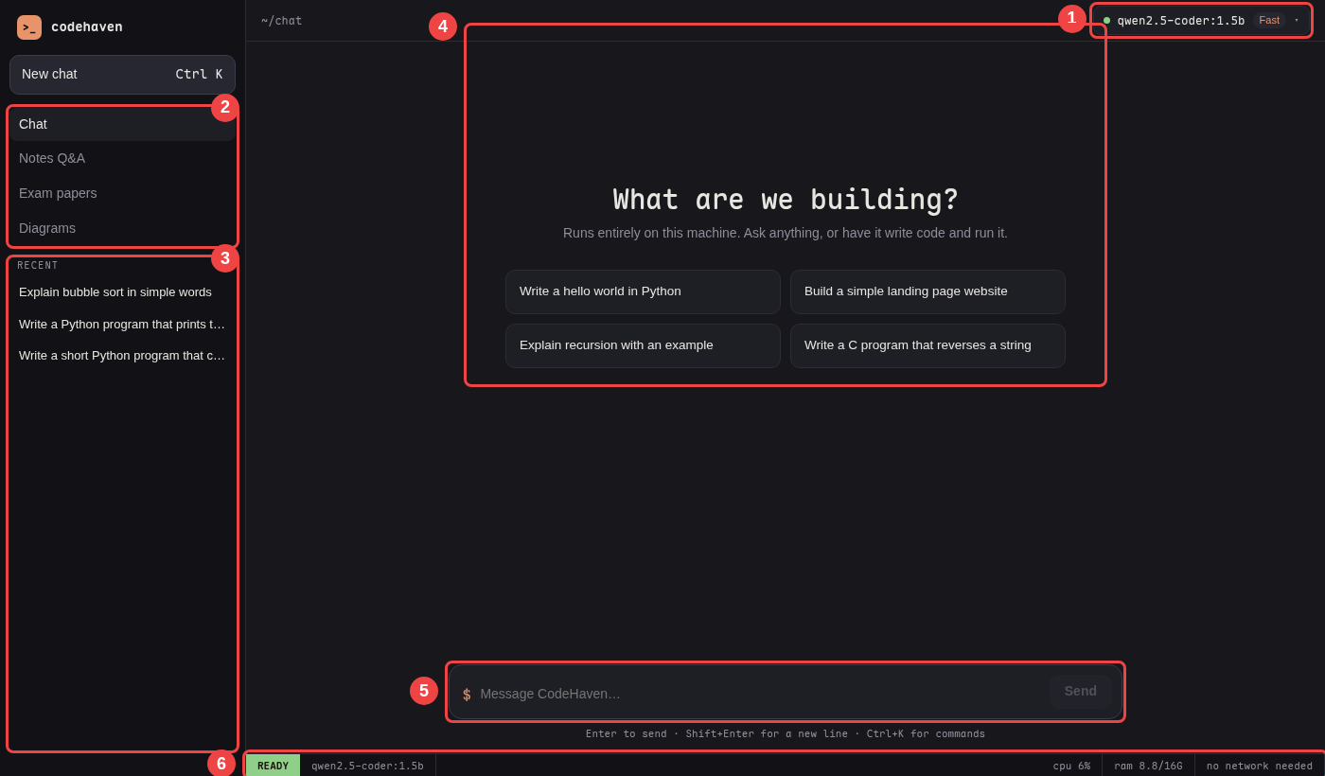
Figure 5: CodeHaven main window: (1) model picker with Fast mode; (2) the four screens; (3) recent chats; (4) chat area with quick prompts; (5) message box; (6) status bar with CPU and RAM

7.1.1 Explanation of Figure 5
The numbered regions are marked on the screenshot. Region 1 is the model picker, which shows the loaded model and the Fast or Deep mode. Region 2 is the side menu with Chat, Notes Q&A, Exam papers and Diagrams. Region 3 lists the recent chats stored on the device. Region 4 is the chat area with the welcome message and four quick prompts. Region 5 is the message box with the Send button. Region 6 is the status bar with the ready state, CPU and RAM use, and “no network needed”.

7.2 Notes & Q&A (RAG)
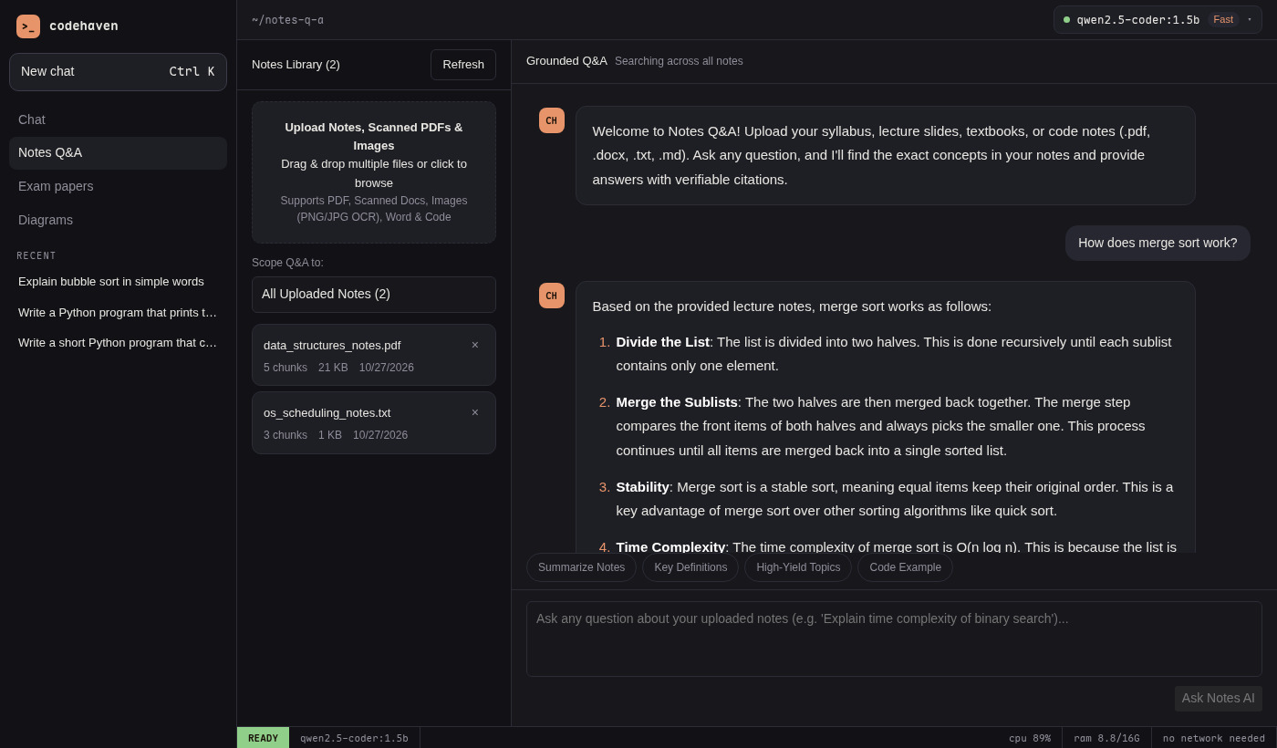
Figure 6: Notes & Q&A (RAG) screen of CodeHaven

7.2.1 Explanation of Figure 6
The Notes Library on the left lists two uploaded notes with their chunks, size and date: “data_structures_notes.pdf” (5 chunks, 21 KB) and “os_scheduling_notes.txt” (3 chunks, 1 KB). An upload box accepts PDF, scanned pages, images, Word and code files, and a “Scope Q&A to” list lets the student choose all notes or one note. The right side is titled “Grounded Q&A”. It shows the question “How does merge sort work?” and the answer, written from the uploaded notes. Quick prompts (Summarize Notes, Key Definitions, High-Yield Topics, Code Example) sit above the question box.

7.3 Exam Generator
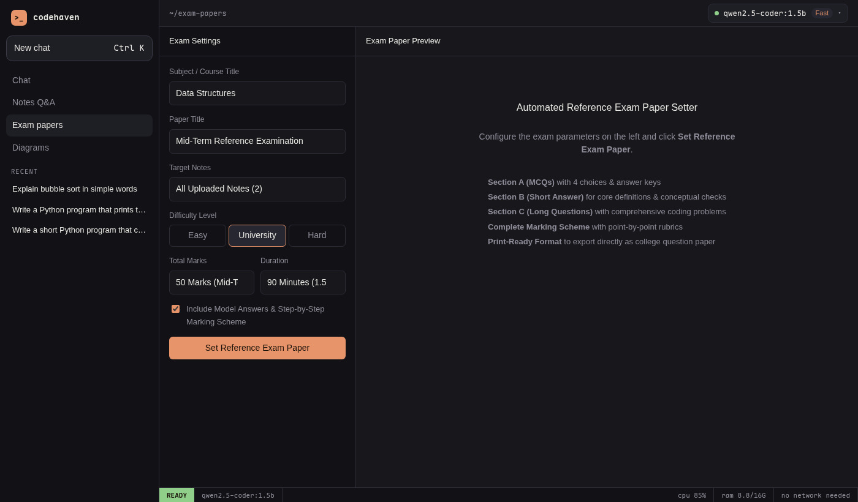
Figure 7: Exam Generator screen of CodeHaven

7.3.1 Explanation of Figure 7
The Exam Settings panel contains the subject / course title (Data Structures), paper title, target notes (All Uploaded Notes), difficulty level (Easy, University, Hard; University is selected), total marks (50 Marks, Mid-Term), duration (90 minutes), a checkbox for model answers and a step-by-step marking scheme, and the Set Reference Exam Paper button. The preview area shows the generated paper with the instructions, Section A (MCQs) with four choices and answer keys, and the later sections: Short Answer, Long Questions and a marking scheme. The paper can be copied, downloaded or printed.

7.4 Generate Code
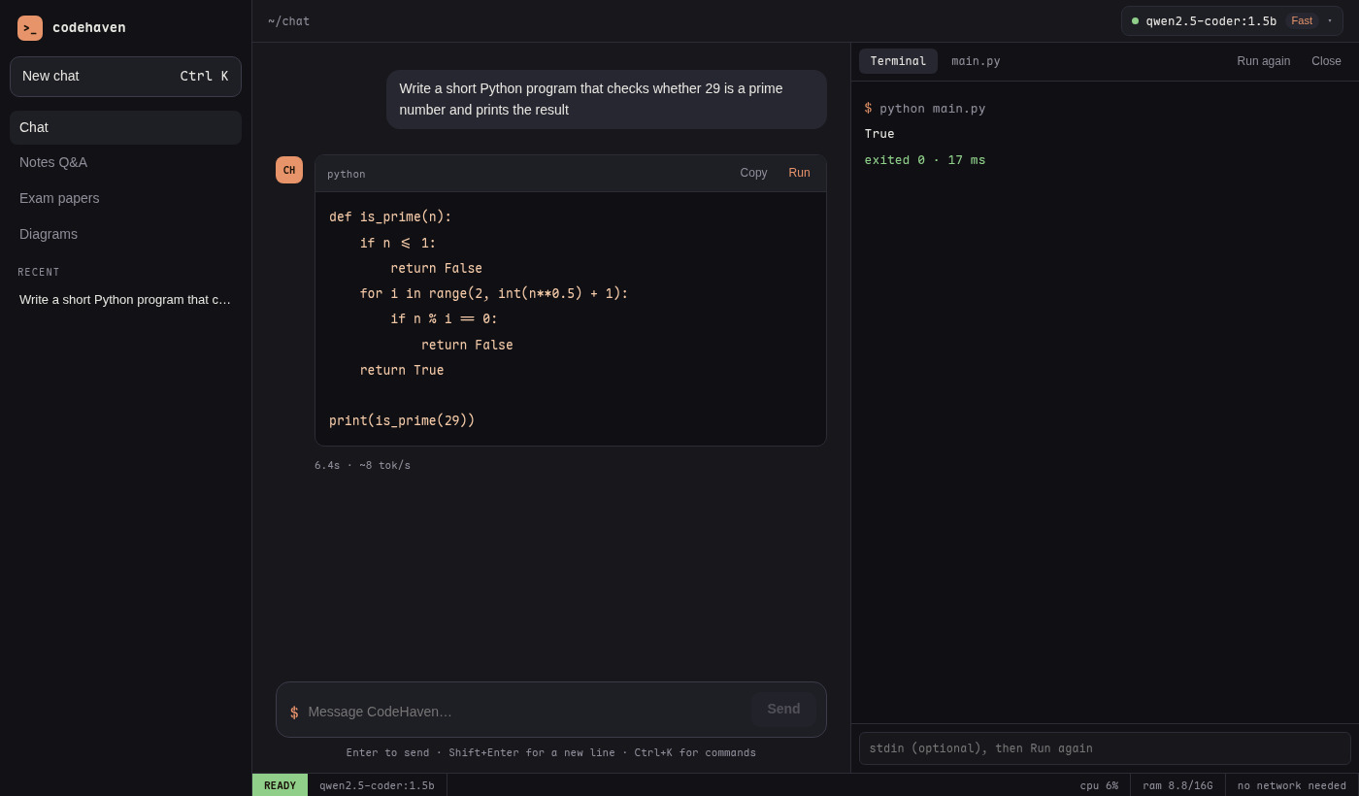
Figure 8: Generate Code in Chat and run it in the Terminal panel of CodeHaven

7.4.1 Explanation of Figure 8
The student asks for a short Python program that checks whether 29 is a prime number. The chat shows the code in one block with Copy and Run buttons. After Run is pressed, the Terminal panel on the right shows the command (python main.py), the output “29 is a prime number.” and the result “exited 0” with the run time. The student can open the main.py tab to edit the code and run it again.

7.5 Debug Assistant
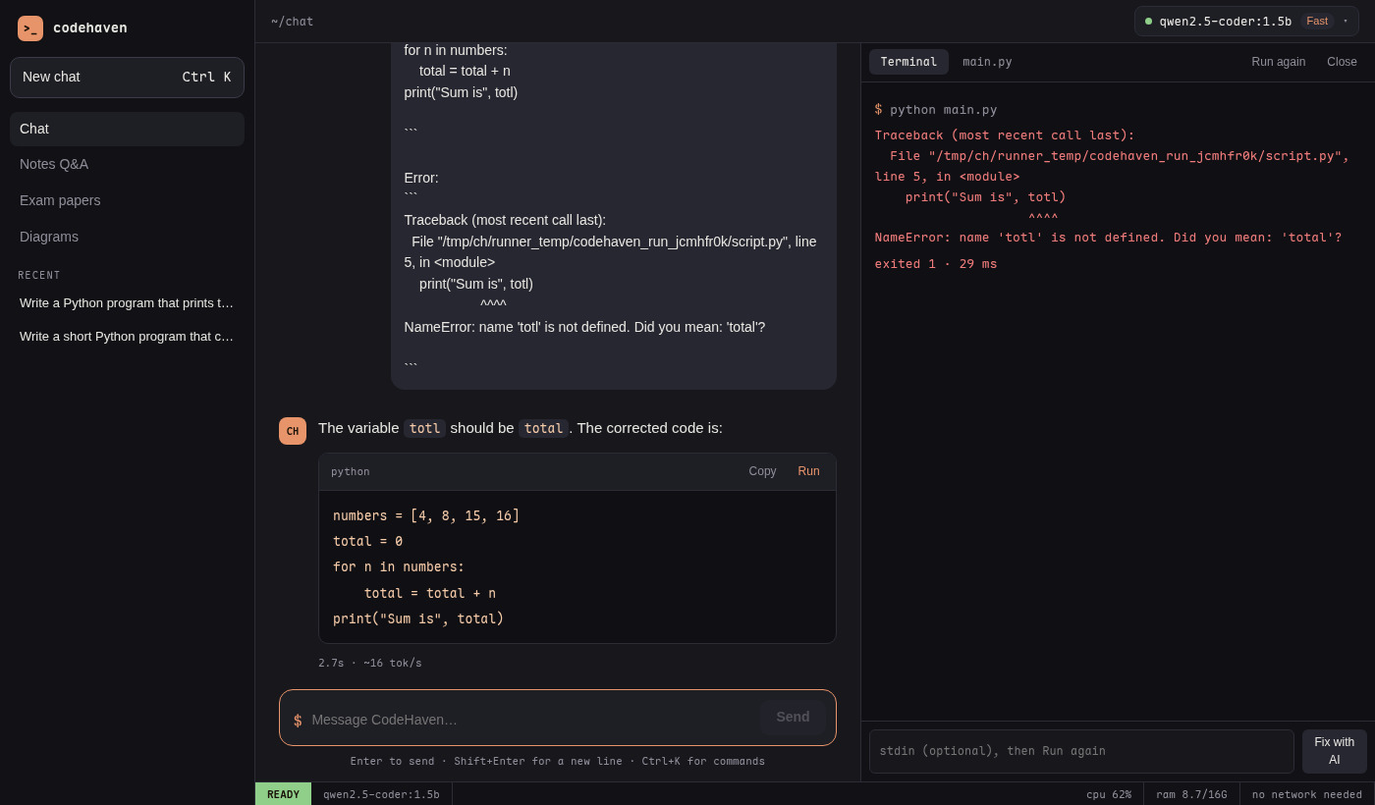
Figure 9: Debug Assistant (Fix with AI) screen of CodeHaven

7.5.1 Explanation of Figure 9
The code in the Terminal panel has a spelling mistake: the variable total is written as totl. The panel shows the traceback with the NameError and a Fix with AI button. When the button is pressed, the chat sends the code and the error to the model. The model explains that totl should be total and gives corrected code in a new block that can be run again.

7.6 Local Storage & History
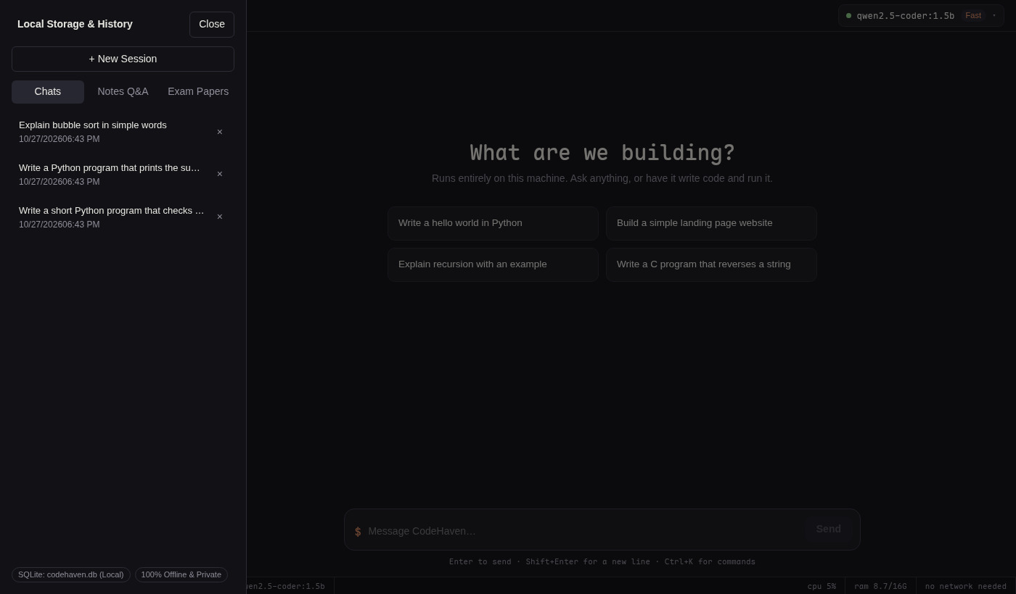
Figure 10: Local Storage & History panel, Chats tab
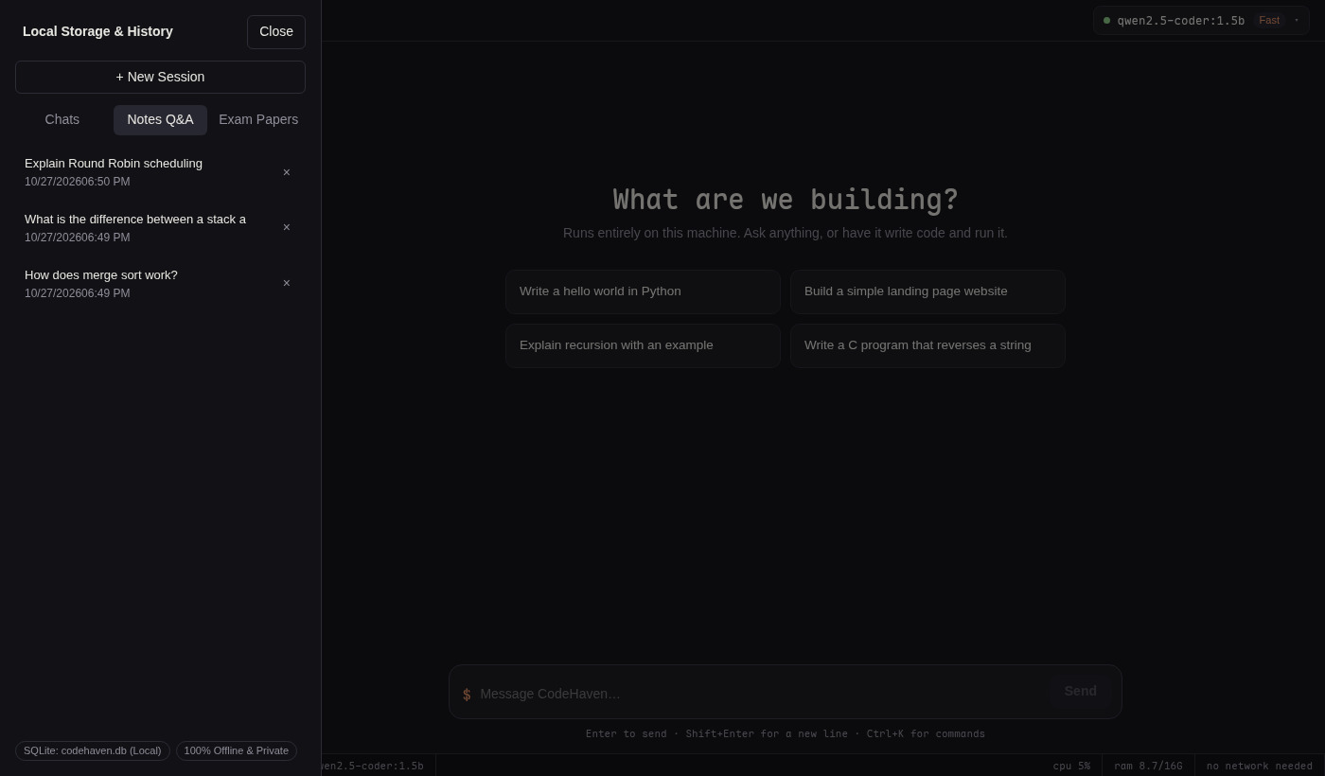
Figure 11: Local Storage & History panel, Notes Q&A tab
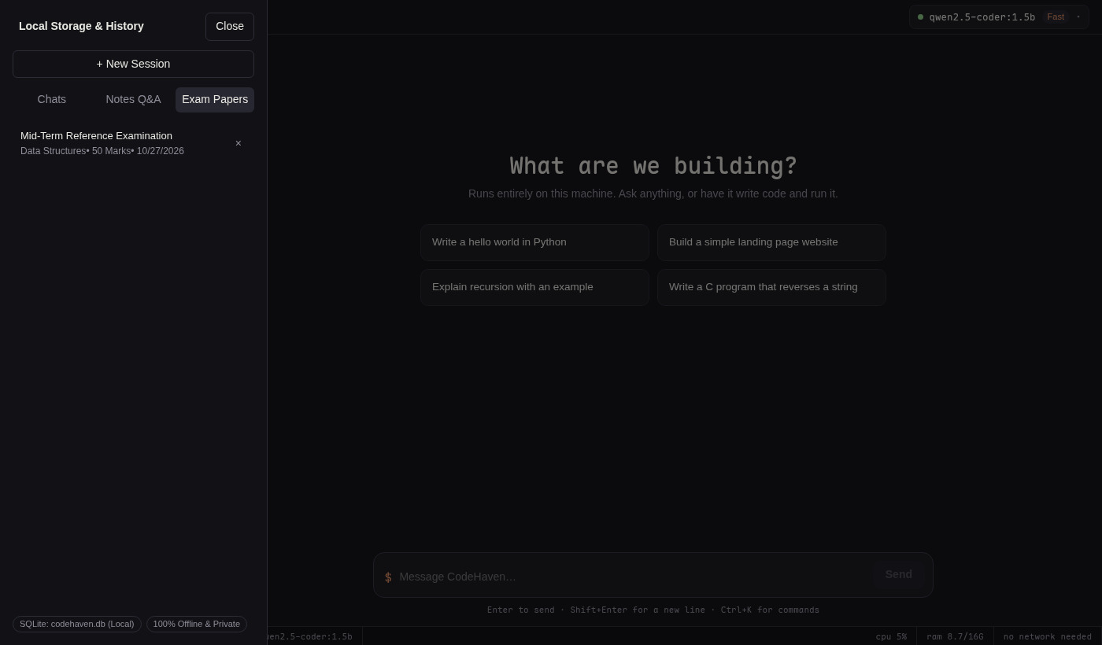
Figure 12: Local Storage & History panel, Exam Papers tab

7.6.1 Explanation of Figures 10 to 12
The Local Storage & History panel has a New Session button and three tabs: Chats, Notes Q&A and Exam Papers. Figure 10 lists the saved chat sessions, Figure 11 lists three saved notes Q&A sessions with their dates and times, and Figure 12 lists one saved exam paper (“Mid-Term Reference Examination”, subject “Data Structures”, 50 Marks). The footer of the panel reads “SQLite: codehaven.db (Local)” and “100% Offline & Private”, which corresponds to the local database of the interface layer.

CHAPTER 8
TIMELINE CHART
The source documents do not record the dates on which project activities were carried out. The chart below is therefore the proposed plan based on the activity durations suggested in the Major Project guidelines of the logbook (12 weeks). It is not a record of completed work. The start date and the status of each activity are [to be filled by the team].
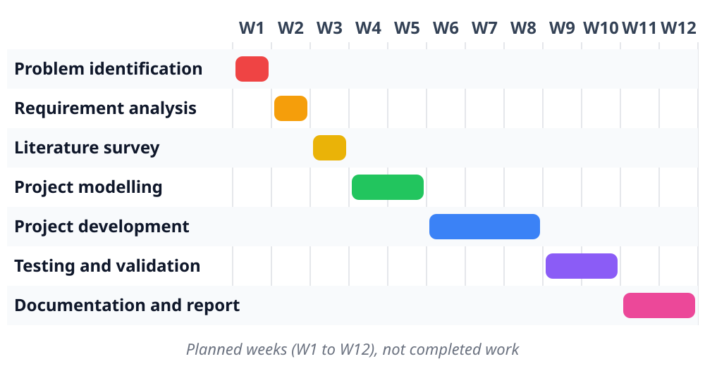
Figure 13: Proposed 12-week project timeline (planned, not completed work)

CHAPTER 9
FUTURE SCOPE
The research paper identifies the directions in Sections 9.1 to 9.4 for further work. Section 9.5 describes a further direction planned by the group.

9.1 Routing between Local and Cloud Models
Nothing in the framework rules out a hybrid setup in which most requests are handled locally and only hard tasks, or ones the user explicitly chooses, go to a cloud API. The authors plan to route requests between local and cloud models based on how hard the task is, keeping privacy and offline use as the default.

9.2 Lower-bit Quantization and Pruning
Lower-bit quantization and pruning are to be tested so that the working example runs well on 8 GB machines.

9.3 Benchmark across Hardware Tiers
A small benchmark is planned that compares local assistants across hardware tiers, including response speed measured on student laptops.

9.4 Larger Models for Better Hardware
Because the hardware sets the limit, a 13B model needs 16 GB of RAM or a GPU to offload layers to. The working example defaults to the smaller model and leaves larger ones as an option for students with better hardware.

9.5 Terminal-Based Local Inference Engine (Lumen Direction)
A further direction, associated with Himanshu Mishra’s Lumen project, is a terminal-based inference engine for running large language models locally. Where it fits with CoreLLM, future development may involve a terminal interface, local model loading, tokenization, transformer execution, key-value (KV) cache management, sampling and inference optimisation. This would extend the study of the inference engine layer (Section 4.2.3), which this report covers through an existing engine (Ollama on llama.cpp), towards understanding how such an engine works internally.
These are planned directions only. None of these features has been implemented or tested as part of this report, and no results are claimed for them.

CHAPTER 10
CONCLUSION
This report presented a five-layer framework for running large language models entirely on local hardware – hardware, model, inference engine, augmentation, and interface and orchestration – and used the CodeHaven offline coding assistant as a working example. The example runs a 4-bit coding model on a 16 GB laptop without a GPU, runs and fixes code, answers questions about a student’s own notes through local retrieval, and makes exam papers, with no step using the network.
Local execution is not a full replacement for cloud LLMs, but it fits well when privacy, offline use or cost matter and the task is well defined. The same choices that remove the network dependency and keep data on the device also limit the assistant to what a 7B model can do.

10.1 Achievement of Objectives
Objective (Section 1.3.1) | Outcome
Explain the five-layer framework | Covered in Chapters 3 and 4 with Figure 1 and Table 3.1
Show why memory limits make quantization a requirement | Covered in Section 4.2.1 and Table 4.1 (about 14 GB at 16-bit versus about 4–5 GB at 4-bit for a 7B model)
Describe the model layer and quantization levels | Covered in Sections 4.2.2 and 4.3 with Table 4.1 and Figures 2 and 3
Explain the inference engine, key-value cache and context length | Covered in Section 4.2.3
Explain local retrieval-augmented generation | Covered in Sections 4.2.4 and 4.4
Describe the interface and orchestration layer | Covered in Sections 4.2.5, 4.6 and Chapter 7
Discuss trade-offs | Covered in Section 10.3 and Chapter 9
Measured performance on student laptops | Not yet done; identified as future work (Section 9.3)

10.2 Key Learnings
- Every layer can be filled with existing tools. Every layer of the framework could be filled with tools that already exist.
- A narrow domain suits a 7B model. Coding help for a known set of languages suits what a quantized 7B model can do.
- The bottom of the stack limits everything above. Memory decides which model can run, and the context length trades off against free memory.
- Retrieval and local storage keep data on the device. The documents, the index and the history stay local, so no network dependency is added.

10.3 Limitations and Trade-Offs
- Capability versus privacy. Quantized local models in the 3–13B range are not as good as the largest cloud models at open-ended reasoning. For narrow tasks with a clear output, such as completing code, explaining an error or answering questions about a given document, they are often good enough.
- Hardware accessibility. Because the hardware sets the limit, not every student gets the same experience. A 4-bit 7B model runs on most current laptops, while a 13B model really needs 16 GB of RAM or a GPU.
- No speed measurements yet. Response speed on student laptops has not yet been measured; it is planned future work.
- Scope of evidence. The benchmark scores reported are published scores from [10], not measurements by the project team.

10.4 Social and Educational Impact
The motivation for the work came from students: the tools need the internet all the time, the free tiers hit rate limits and people are not comfortable sending their own code to an outside server. A framework that keeps the model, the documents and the history on the student’s own laptop addresses these three concerns without a cloud account.

10.5 Final Remarks
The project provides a clear, source-based foundation for understanding how a large language model inference engine fits into a complete local system. The CoreLLM-specific implementation and test results will be added by the team as they become available.

REFERENCES
[1] A. Vaswani et al., “Attention is all you need,” in Proc. Adv. Neural Inf. Process. Syst. (NeurIPS), 2017.
[2] H. Touvron et al., “LLaMA: Open and efficient foundation language models,” arXiv:2302.13971, 2023.
[3] J. Xu et al., “On-device language models: A comprehensive review,” arXiv:2409.00088, 2024.
[4] E. Frantar, S. Ashkboos, T. Hoefler, and D. Alistarh, “GPTQ: Accurate post-training quantization for generative pre-trained transformers,” in Proc. Int. Conf. Learning Representations (ICLR), 2023.
[5] J. Lin et al., “AWQ: Activation-aware weight quantization for on-device LLM compression and acceleration,” in Proc. Machine Learning and Systems (MLSys), 2024.
[6] G. Gerganov, “llama.cpp: LLM inference in C/C++,” GitHub repository, 2023. [Online]. Available: https://github.com/ggerganov/llama.cpp
[7] P. Lewis et al., “Retrieval-augmented generation for knowledge-intensive NLP tasks,” in Proc. Adv. Neural Inf. Process. Syst. (NeurIPS), 2020.
[8] A. Radford et al., “Robust speech recognition via large-scale weak supervision,” arXiv:2212.04356, 2022.
[9] Ollama Inc., “Ollama: Get up and running with large language models locally,” 2024. [Online]. Available: https://ollama.com
[10] B. Hui et al., “Qwen2.5-Coder technical report,” arXiv:2409.12186, 2024.
Source paper: “A Foundational Approach to Local Large Language Model Execution”, Information Technology, M. H. Saboo Siddik College of Engineering, Mumbai.

